#### 

#### Date:

#### Pricing Quotation

**From**

|  |  |  |
| --- | --- | --- |
| **MR. KARUNESH ZAVERI** |  | **Quotation # 00632** |
| SURAT, GUAJRAT, INDIA - +91 – 99981 97025 |  | **Terms:** |
| Quotation To |  | **Salesperson: Karunesh Zaveri** |
| **MR. ANAND KEDIA – GOLDEN JD.** |  | **Ship Week Of:** |
| SURAT |  |  |

|  |  |  |
| --- | --- | --- |
| **Order #** | **Delivery Via:** | **Routing:** SURAT CHANNEL PARTNER |

|  |  |  |  |  |  |  |
| --- | --- | --- | --- | --- | --- | --- |
| **Item** | **Quantity** | **Description** | | **Per Unit** | **Total Amount** | |
| **1** | **4 Nos** | **VTS – GOLD**  **SPECIAL DISCOUNT:** ~~INSTALLATION CHARGES~~ | | **9500.00**  **~~500.00~~** | **38000.00**  **~~2000.00~~** | |
| **Total** | | | **38000.00** | |

|  |  |  |
| --- | --- | --- |
| **Special Instructions** | Date | Approval Signature |
|  | Purchaser Signature | |
|  | Title | |

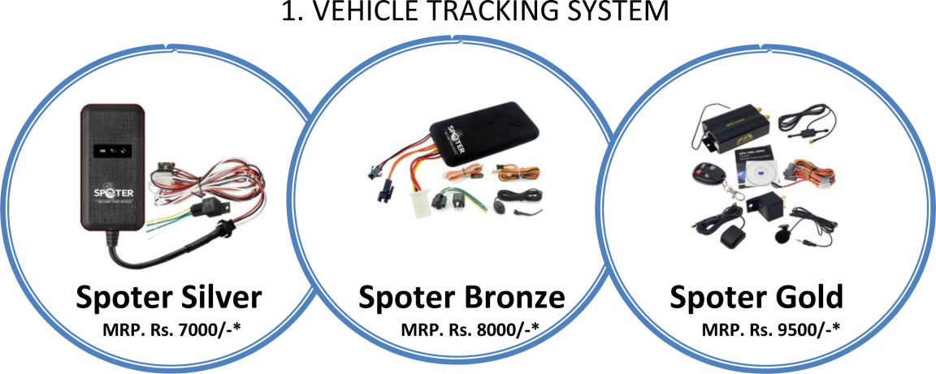

|  |  |  |  |  |
| --- | --- | --- | --- | --- |
| SL NO. | KEY FEATURES | SILVER | BRONZE | GOLD |
| 1 | Track your vehicle in real time. | Yes | Yes | Yes |
| 2 | Get reports of each vehicle's daily activities. | Yes | Yes | Yes |
| 3 | Real-time monitoring and on board data storage. | Yes | Yes | Yes |
| 4 | Online tracking with motion directions. | Yes | Yes | Yes |
| 5 | Geo-fencing/location /power off/ Over speed alert. | Yes | Yes | Yes |
| 6 | Send sms to get current location of vehicle on mobile. | Yes | Yes | Yes |
| 7 | Shortest path finder. | Yes | Yes | Yes |
| 8 | Multi-Geo fence | Yes | Yes | Yes |
| 9 | 1yr. Server, Storage, data Charge Paid | Yes | Yes | Yes |
| 10 | Detailed trip report. | Yes | Yes | Yes |
| 11 | ACC ignition detection, vehicle status notification | Yes | Yes | Yes |
| 12 | External SOS button, used in immergence case use | No | Yes | Yes |
| 13 | Build-in back up battery,  support illegal main power cut-off alarms | Yes | Yes | Yes |
| 14 | External Relay, used to cut off engine power or oil remotely | Yes | Yes | Yes |
| 15 | External Microphone, used in voice monitoring case | No | Yes | Yes |
| 16 | Door open /shock alert | No | No | Yes |
| 17 | Idling vehicle report. Hijack recovery system through engine shutdown. | Yes | Yes | Yes |
| 18 | Turn off vehicle remotely during theft. Speeding notifications. | Yes | Yes | Yes |
| 19 | Commands from your cell phone. Mileage statistics Door Locking | No | No | Yes |
| 20 | USB configuration (option) | Yes | Yes | Yes |
| 21 | SOS emergency alarm. | No | Yes | Yes |
| 22 | Optional Fuel Censor compatible | No | No | Yes |
| 23 | Internal Antenna | Yes | Yes | No |
| 24 | Inbuilt Geo Storage by SD card | No | No | Yes |
| 25 | External GPS Antenna and GSM Antenna | No | No | Yes |
| 26 | RFID Remote Controller | No | No | Yes |
| 27 | Streaming technology Support | No | No | No |
| 28 | 1 Yr. warrantee | Yes | Yes | Yes |
| 29 | Works on 9V to 24V | Yes | Yes | Yes |
| 30 | Reset Configuration | Yes | Yes | Yes |
| 31. | Yearly Renewal After First year | **3000/-** | **3600/-** | **3600/-** |
| 32. | Extended Warrantee for One Year | **2000/-** | **2000/-** | **2000/-** |